

**Building the Global Adaptation Institute Index**

**GaIn™**



NASA

**Produced by the Global Adaptation Institute, which retains all rights.**

**Not for quotation or circulation without the Institute’s written permission.**

**Washington, DC**

**March 18, 2011**

**Contents**

Foreword 3

Executive Summary 5

Introduction 7

The Model 8

Implementation 8

Gain™ Structure 8

Weighting Indicators 11

Methodology 11

Readiness Categories and Indicators 13

Economic 14

Social 14

Governance 15

Adaptometer 16

Vulnerability Categories and Indicators 17

Biophysical exposure and impact 18

Socioeconomic exposure 19

Socioeconomic adaptive capacity/resilience 21

Energy/Other sectors 22

Results 23

Ranking table 23

Readiness Bar plot 25

Vulnerability Bar Plot 25

Stacked bars 26

GaIn™ Map 26

Matrix 27

Change in readiness 28

GDP correlations 28

Next Steps 34

References 35

Appendix 1: Methodology 37

Appendix 2: Glossary of Terms 38

Appendix 3: October 27 Bolger Center Scientists Meeting (2010) 39

Appendix 4: Roadmap (tentative) 40

**Big issues:**

* **Scale**
* **Readiness mess**
* **Vulnerability as multiplicative, not additive**

# Foreword

**Who We Are**

The Global Adaptation Institute is a non-profit environmental organization guided by a vision of building resilience against climate change and other global forces as a key component to sustainable development. Our mission is to enhance the world’s understanding of the urgency for adaptation to climate change and other global forces and for the support needed through private and public investments for developing countries.

**Our Vision and Values**

Our view is pragmatic. Climate change is a reality and is already having an impact. These effects are being compounded by other global trends – population growth, migration and urbanization, and economic development. Right now, the greatest impact is on the poorest countries and populations, those least able to respond. Some adaptation projects can reduce the vulnerability of society to climate change in months. Others require decades. The key need is for more -- and more effective -- adaptation efforts to ramp up now so as to complement emission reduction efforts in reducing the impacts of climate change.

**Our Objectives**

Our priority is to see real results and real benefits, immediately.

We will raise awareness. We will help to mobilize the private sector. We will develop metrics, indicators, and other rigorous tools to help produce the greatest positive impact from resources used. We will directly fund pilot projects in adaptation and assist other private and public donors to do the same.

We will forge partnerships with other groups that share this positive vision that enabled us to bring together 30 leaders from five continents to work on adaptation solutions and to gather 15 distinguished international experts and scientists for our first workshop on global adaptation metrics.

**Measuring What Matters**

How can adaptation be made most effective? Where is the need the greatest? Which countries are most resilient to climate challenges? Which adaptation investments will bring the greatest benefits for the largest number of people? What are the impediments to greater investment in adaptation?

An important task of the Global Adaptation Institute is to work with experts and scientists to develop rigorous metrics and indicators so that scarce resources are not wasted, but instead produce the greatest possible benefits.

This document is a description of how GaIn™ has developed its first iteration of a model that measures a country’s Readiness to Adapt to several challenges, including climate change and its Vulnerability to this and other global trends. This is a draft model only and GaIn™ looks forward feedback from a wide array of scientists, economists, policymakers, and representatives of NGOs, think tanks and the private sector.

The GaIn™ model is intended first and foremost to be a tool that decision makers can use to *save lives*. While there have been many tools that can assist policymakers, businesses, scientists, and other users in determining risks from climate change and other major trends, our goal is to create a model that moves beyond prediction to action. Our tool is intended to be pragmatic, actionable, and oriented toward delivering improvements in climate resilience as well as in enhancing the business environment in all countries.

The GaIn™ model is currently based on 18 indicators taken from a variety of data sources. These indicators reflect the judgments of international institutions, think tanks, scientific bodies, and trade associations on what data most accurately represent the social or biophysical phenomena measured. We have tried to use well-respected sources but will be open to alternate suggestions as we solicit feedback in the coming months.

**Conclusion and Next Steps**

Agreement on metrics for adaptation to climate change and other global trends has yet to come to pass. It requires convergence from development, climate, ecosystems, investment, public policy, and governance experts. However, GaIn™ believes that the world should not wait for international agreement before action is taken. We believe we should act quickly in those sectors we know are vulnerable to climate change and other global trends AND crucial to human well being.

This document presents the first working model of the Global Adaptation Index and preliminary results. We encourage reviewers to provide feedback, coments and criticism.

Moving forward, GaIn™ will:

* Pursue several rounds of consultation with scientists, economists,policymakers, and representatives of NGOs and think tanks to fine tune our model.
* Develop a communications and outreach strategy with the private sector, NGOs, and government institutions to receive more feedback, ensure that our model is on track, pragmatic and useful, and help us disseminate information.
* Release a Version 1.0 in late summer/fall for policymakers to begin implementing Adaptation efforts.
* Continue to improve our metrics while seeking to partner with others in promoting adaptation projects most likely to improve resilience in sectors most important to human prosperity, stability, and health.
* Identify additional drivers such as energy
* Design and implement a plan to capture “awareness” and produce the“adaptometer”

# Executive Summary

This document describes the first working draft for GaIn™. It explains how and why indicators were chosen to measure a country’s Readiness (to adapt) and Vulnerability to the impacts of climate change and other global trends It also shows how the indicators are combined to produce the overall measure of both Readiness and Vulnerability. We anticipate many changes and improvements in our draft model. However, we believe this model reflects a sensible approach based on our present understanding and review of numerous indices and academic papers.

This work builds upon the GaIn™ Oct. 2010 experts meeting (See attendees on Apendix 3) on global adaptation metrics, indices, and indicators. A sense that adaptation metrics are untested, hindered by fragmented expertise, and politically contentious emerged from this meeting. Further review and expert consultation has born this out. However, we can usefully build upon the work that has been done. Following advice from this meeting, the GaIn™ working team has used existing indices and/or frameworks as much as possible and included indicators that are transparent and easy to understand by stakeholders.

Also, GaIn™ has closely heeded warnings that uncontrollable exogenous factors not dominate the rankings while still being accounted as contributors to vulnerability. As explained in the Vulnerability section, we feel that classifying indicators into those that can be changed quickly and those primarily biophysical exogenous factors can motivate users to change those indicators they can change while understanding the contributions of less controllable factors.

Initially, we undertook a broad, in-depth review of the climate adaptation literature and the potential indices (see bibliography). This step provided insight into the categorization of indicators and their usefulness. Second, we consulted several in-house experts to review our initial methodology and indicator selection. Third, we used both qualitative and quantitative methods to ensure that indicators were relevant and not overlapping or overly-correlated.

Throughout our indicator selection process, we tested each indicator against several quality control criteria.

* Coverage: Does the indicator cover sufficient countries to ensure global representation?
* Access: Are the data easily available and open to the public for scrutiny?
* Credibility: Is the institution responsible for conceptualizing or collecting data on the indicator authoritative, often-cited, and experienced in the subject matter?
* Effectiveness: Is the chosen indicator appropriate for representing the condition we are measuring or are there potentially better ones for which data must be collected?
* Longevity: Will the indicator likely exist for many years?

Readiness indicators are divided into three categories -- Economic, Social and Governance. The indicators chosen to represent each are the Index of Economic Freedom, Human Development Index, and World Governance Indicators. Eventually a fourth category, “Awareness,” which will consist of country surveys developed by GaIn™ in consultation with experts will be included.

Vulnerability indicators are divided into three categories -- Biophysical Exposure, Socioeconomic Sensitivity, and Adaptive Capacity. This categorization and sector selection is based primarily on a model developed by Hans-Martin Fussel (2010). Initially each vulnerability category contains an indicator to reflect changes in each of four sectors, Food, Water, Health, and Coastal Zones. Additional sectors such as energy, agriculture/ecosystems and infrastructure may be included in the future. Indicators within each of these categories can be described as slow, medium and fast adjusting indicators. GaIn™ believes this description will help countries better understand improvement in which indicators are likely to “move the needle” the most.

An overall Readiness and Vulnerability score is calculated by weighing the standardized scores for each indicator and summed as described below. The total GaIn™ score is the total Readiness minus total Vulnerability, leading to the global GaIn™ ranking ([link](https://docs.google.com/viewer?a=v&pid=explorer&chrome=true&srcid=0B4xJVrXz_YHIM2ViYTk0M2ItNDk2My00NmMwLThiNDEtOGZiZGU0ODQ4NDhl&hl=en&authkey=CIib9_4H)[1]).

We also prepared a short [presentation](https://docs.google.com/present/edit?id=dw7tgvh_134hnrmnhg2&authkey=CISctoQG) with slides depicting the process.

# Introduction

The Global Adaptation Index, GaIn™, is being developed by the Global Adaptation Institute <http://www.globaladaptationinstitute.org/> as a tool to help leaders in the public and private sectors to implement urgent actions to increase the readiness of developing countries to Adapt faster.

Countries are urgently called to be prepared and if possible to capitalize on the effects of climate change and other global trends, like population growth, urbanization, and economic growth. Resources have been committed from international institutions, but it is not going to be enough. The private sector will play a key role in the investments that are needed. GaIn™ will become the navigation chart that will guide investments both public and private. Countries will have a rating according to their level of readiness and their vulnerability. Such rating will be transparent, pragmatic and simple; and will contribute in determining the allocation and prioritization of financial and technical resources for Adaptation.

In addition GaIn™ wil be a user-friendly simulation and analytic tool that will help decision-makers to understand and act upon those drivers of change that can increase a country’s capacity to adapt and thus better prepare people for climate change and other global forces and increase their well being.

Gain ™ is being built upon the readiness matrix and the inputs we have received from Heads of State, Scientists, Business leaders, NGOs and other stakeholders in informal discussions that have taken place between December 2010 and January 2011, including in Davos, Mexico (both Cancun and DF), Colombia, Chile, USA, the White House.

# 

# The Model

This section describes step-by-step how values are assigned to countries for each indicator and how they are then combined to create Readiness and Vulnerability scores.

## Implementation

This first working model for GaIn™ was implemented using Google Docs Spreadsheets. The complete model, resources, indicators, weights, calculations and results are available at [this address](https://spreadsheets.google.com/ccc?key=0AoxJVrXz_YHIdFZIcE9NbDBJX1ZSaFZxSi13UnhhVGc&hl=en&authkey=COKhgYAC%23gid=2). There is open access to view, but not to edit the parameters or data. The model is for circulation only within the limited consultation group. Please do not share with those outside this process.

The current version approaches the operational limits of Google docs, therefore, a future version will use another format. Since we aim to maximize transparency, open source and OpenData for GaIn™, future development, beyond this version, will be in another framework.

## Gain™ Structure

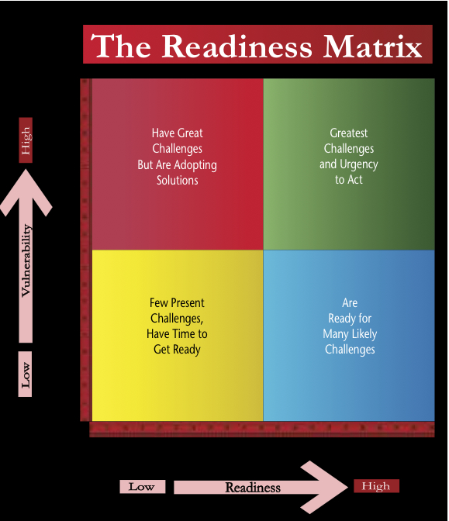 In late 2010, we developed a way to visualize a country’s comparative resilience based on their Readiness for and Vulnerability to climate change and environmental changes. Based on these factors, a country will fall into one of four categories, such as highly vulnerable yet prepared or low vulnerability and low preparedness. The vertical axis measures the relative vulnerability of countries while the horizontal axis measures to what degree a country is prepared to deal with climatic and environmental changes.

The Readiness Matrix as shown at the launch of GaIn™ has two axes, Readiness and Vulnerability.

The work that follows on this document presents the progress in populating the Matrix with real cases based on selection of indicators for the “Readiness axis” and the “Vulnerability axis”. The rest of this section is a brief scheme and description of the indicators used. The following sections give exhaustive explanations for each Category and Indicator. Then we describe the methodolody and weighting factors. Finally we present some preliminary results and examples of practical cases.

**Readiness Axis:** A country’s existing preparations and ability to adapt to a changing climate.The axis has 3 categories: Economy, Social, and Governance and a placeholder for Awareness. A weighting is shown below each indicator within the three categories:

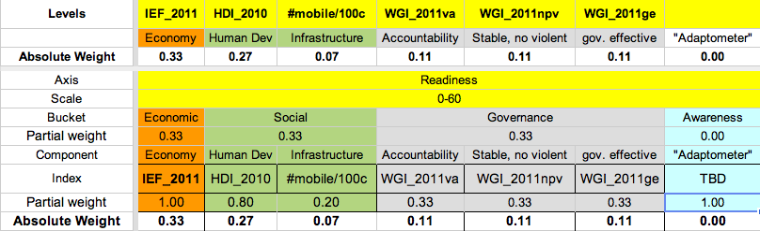

The three categories receive equal weight (33%). Indicators within the categories (and their weights) are:

**33% Economic:** Ability to provide a hospitable financial and regulatory investment environment.

**100%** Index of Economic Freedom 2011.

**33% Social:** The human and physical capital available to transform investments into effective projects and climate resilient enterprises.

**80%** Human Development Index 2010 [UNDP].

**20%** Infrastructure. Proxy: mobile phones per 100 people, in 2009. [ITU]

Rapid access to information, communication [There is something missing here]. that enables an economy to respond quickly to a crisis.

**33% Governance:** Strong institutions will ensure that investments more effectively meet the needs of the population.

From the World Governance Indicators 2009 we chose 3 sub-components that do not overlap with the Index of Economic Freedom. They are equal weighted [Kaufmann]

**33%** Voice & Accountability.

**33%** Political Stability & No Violence.

**33%** Government Effectiveness.

**Vulnerability Axis**: Captures exposure to climate related hazards, sensitivity to their impacts and the current ability to cope with those impacts. Vulnerability, as represented below, has 3 categories (rows), and 4 key sectors indicators for each category (columns). In this initial version of the index a single indicator was selected for each of the sectors within each of the categories. Each category has equal weight, but the indicators for the specific sectors have different weights, namely food = 0.33, water = 0.33, health = 0.22, coastal = 0.11. The index represents high vulnerability by larger scores which means that the weighting for some indicators is negative. These are shown below.

|  |  |  |  |  |  |
| --- | --- | --- | --- | --- | --- |
|  | **Food** | **Water** | **Health** | **Coast** |  |
| **Biophysical Impacts** | Crop yield  0.11 | Precip. dec.  0.11 | Dis. pop.  0.07 | Coast Area  0.03 | Slow Indicators |
| **Socioeconomic Exposure** | Rural pop.  0.11 | Freshwater  0.11 | #doctor/nurse  -0.07* | Coast pop  0.03 | Medium Indicators |
| **Socioeconomic Adaptive Capacity** | Hunger  0.11 | Pop w/ water  -0.11* | Infant mort.  0.07 | Coast wealth  -0.03* | Fast Indicators |

* Indicators with negative values measure the contrary of vulnerability. They subtract towards the final score.

The indicators used are:

**33% Biophysical Impacts:** The level of exposure to adverse biophysical impacts for a given magnitude of climate change (slow adjusting).

33% Food: Predicted cereal crop yield decrease per country [Wheeler based on Cline]

33% Water: Projected future percentage precipitation decrease [CRU & 9 model A2 scenario]

22% Health: Proportion of population affected by climatic events in recent decades [CRED]

11% Coast: Percent of national land area less than 5m above sea level [PLACE]

**33% Socioeconomic exposure:** The importance of a climate-sensitive system or sector for a country (adjust at medium rate).

33% Food: Percentage of total population classified as rural [WB]

33% Water: Annual freshwater withdrawal [WB]

-22% Health: Doctor/Nurse numbers per 1,000 [WB]

11% Coast: Percent of population living less than 5m above sea level [PLACE]

**33% Socioeconomic Adaptive Capacity:** The availability of economic, social, and institutional resources [for specific sectors] to cope with and adapt to the impacts of climate change (fast adjusting).

33% Food: Depth of hunger measured as deficiency in Kcal/person/day [WB]

-33% Water: Percentage of population with access to water and sanitation [WB]

22% Health: Infant Mortality per 1000, 2009 [WB]

-11% Coast: Measure of financial resources that might be applied to coastal protection: $PPP per km2 of coast area [WB and PLACE]

## Weighting Indicators

Whenever possible we try to obtain a complete set of the best, most general, independent, and comparable Indicators. Therefore, our preference is to weight all components equally. These are the exceptions:

* We weight Readiness stronger than Vulnerability because of our focus on promoting societal and governmental change and investments that create tangible improvements -- Vulnerability indicators are more static. Therefore, to compute the total country scores, we rescale Readiness scores to a global maximum of 60 and Vulnerability to a global maximum of 40.
* The Awareness component is not yet ready, and therefore currently has 0 weight.
* The Human Development Index (HDI) measures social Readiness. We also include an infrastructure and communications component that reflects physical capital which is not captured in HDI. HDI receives 80% of the social category weigh and the number of mobiles per 1,000 habitants receives 20%.
* For Vulnerability, the Food and Water sectors receive stronger weights (33%). Health is weighted slightly less (22%), and Coast has the weakest weight (11%). This weighting scheme reflects an emphasis on sectors GaIn™ believes to be more important to our mission of improving lives and investing in sectors than can have the highest impact in reducing vulnerability. Improvement in Food and Water sectors will also contribute to improvements in Health, so the effective weighting for Health is high.

## Methodology

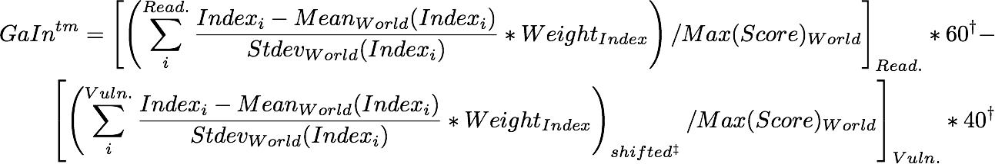

Footnotes:

† For the total Score, Readiness is scaled to 60, and Vulnerability to 40.

‡ Vulnerability score can be negative, we shift everything so it starts in zero.

* 1. Each Indicator is converted into standardized scores (z-value) within available countries.
  2. Scores for each Indicator are weighted and aggregated (sum).
  3. Since summed vulnerability scores can be negative, Vulnerability scores for each country are equally shifted to make the most negative score equal to zero.
  4. Scores for each axis are rescaled (max 60 for Readiness, max 40 for Vulnerability).
  5. The overall GaIn™ score is calculated as Readiness minus Vulnerability, producing a global ranking.
  6. We also produce the percentage *change in Readiness* score over the past 5 years. In this case the scores are not the latest value as above, but the change between the latest and 5 year previous scores divided by the geometric mean of those two scores. Indicator weights remain the same. The weighted sum of these percentage changes are the total “change in Readiness” score.

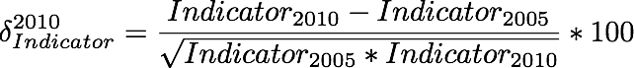

# 

# Readiness Categories and Indicators

The Readiness indicators aim to measure a country’s existing preparations and ability to adapt to a changing climate. This focus is similar in spirit to the World Bank’s Country Policy and Institutional Assessment (CPIA) measurements, which determine development assistance funding for low income countries based on performance in implementing policies that promote economic growth and poverty reduction.

We reviewed many different economic indices, such as the Word Bank’s Doing Business Indicators (DBI), the Heritage Foundation’s Index of Economic Freedom (IEF), and Transparency International’s Corruption Perception Index (CPI). All are excellent indicators. There is overlapping among these, as a sub-component of one index will be based on a sub-component of another. We ultimately chose to use the IEF because it uses many DBI indicators and includes the CPI.

To minimize overlapping, we use a minimum of indices that cover most of the information concerning effective economic governance and human development. Still, as a general trend, these indicators align with each other, and with GDP (or GNI) per capita. As such, we can also investigate deviations from the GNI trend as, e.g. countries with extensive oil resources.

Currently, we provide both “Readiness” and “Improvement in Readiness” scores. Hence, while Country A and Country B may score equally for Readiness, Country A’s *improvement* in the last 5 years on these indicators may be considerably more. This information is important to investors who may want to invest in riskier but high return countries (low initial Readiness but significant improvement in Readiness). As Daniel Kaufmann has emphasized in consultation with GaIn™,[2] users and end clients are often primarily concerned with determining how they can improve upon indicators measured -- breaking our analysis down into improvement in Readiness can help users interested in improving measure this progress.

Partitioning Readiness into governmental, economic, and social indicators can communicate to countries and investors how countries are performing in these three areas. In addition, users of the index can more easily pinpoint specific indicators of interest through this partitioning.

GaIn™ intends to develop a fourth category, “Awareness,” to complement these three categories. This category would be subjective and provide information on whether national and local governments are aware of how sensitive their jurisdictions are to climate impacts and, if so, how they plan to adapt.

## Economic

**Indicator 1: Index of Economic Freedom [Heritage Foundation]**

*Component Indicators:* Business freedom, trade freedom, fiscal freedom, government spending, monetary freedom, investment freedom, financial freedom, property rights, freedom from corruption, labor freedom.

*Explanation:* This indicator uses information from the Doing Business Index and the Corruption Perception Index while covering several additional economic variables. Particularly for the investment community, this indicator reflects the ability of a country to move quickly and effectively to address climate challenges. Improvements indicate that a country is better able to efficiently and quickly utilize investment capital.

*Coverage*: 183 countries

*Access*: Accessible.

*Credibility*: Credible. Produced by The Heritage Foundation and Wall Street Journal.

*Effectiveness:* Good. Comprehensive. Includes key indicators of concern to investors.

*Longevity*: In existence since 1995. While the Heritage Foundation and Wall Street Journal are prominent in their fields, NGOs can change, merge, or lose funding.

*Source*: [http://www.heritage.org/index/](http://www.google.com/url?q=http%3A%2F%2Fwww.heritage.org%2Findex%2F&sa=D&sntz=1&usg=AFQjCNGQZ6skokRvi1-7UyGzOvh5krb4IA)

## Social

**Indicator 2: Human Development Index [UNDP]**

*Component Indicators:* Health (Life expectancy at birth), Education (Mean years of schooling and Expected years of schooling), Living standards ( Gross national income per capita)

*Explanation*: Index reflects the health of the people within a nation and overall human capital. Improvement in this indicator reflects the increased readiness of the population to provide the necessary human capital to implement adaptation initiatives.

*Coverage*: 177 countries

*Access*: Accessible.

*Credibility*: Credible. Conducted by UNDP since 1990.

*Effectiveness:* Good.

*Longevity*: In operation since 1990.

*Source*: [http://hdr.undp.org/en/statistics/hdi/](http://www.google.com/url?q=http%3A%2F%2Fhdr.undp.org%2Fen%2Fstatistics%2Fhdi%2F&sa=D&sntz=1&usg=AFQjCNFDVsqZXA9A_y1V8r2M8ElDfLmAHg)

**Indicator 3: Mobile cellular subscriptions (per 100 people) [ITU]**

*Component Indicators:* Mobile cellular subscriptions (per 100 people)

*Explanation*: Mobile phones serve as a proxy for infrastructure and access to information and knowledge. They are relevant in many sector and activities, such as personal communications, enabling new economic ( e.g. microfinance), healthcare management or crisis response, among others.

*Coverage*: 233 countries

*Access*: Accessible.

*Credibility*: Credible. ITU.

*Effectiveness:* Good. Not tested or used in other models. Makes sense to GaIn™ for now.

*Longevity*: Strong longevity, unless a new technology appears that replaces the usefulness of mobiles as an indicator. This data has been gathered since 1980**.**

*Source*: http://data.worldbank.org/indicator/IT.CEL.SETS.P2

## Governance

**Indicator 4: World Governance Indicator - Voice & Accountability**

*Component Indicators*: Comprised of many indicators. Part of the World Governance Indicator.

*Explanation*: This indicator reflects the ability of a country to respond to its people’s natural resource allocation needs. Improvement indicates that a country’s government will be more responsive to the biophysical and capacity needs of its citizens as the climate changes.

*Coverage*: 199 countries

*Access*: Accessible.

*Credibility*: Credible.

*Effectiveness:* Good.

*Longevity*: Around since 1996. Should be published for foreseeable future unless underlying methodology changes.

*Source*: [http://info.worldbank.org/governance/wgi/resources.htm](http://www.google.com/url?q=http%3A%2F%2Finfo.worldbank.org%2Fgovernance%2Fwgi%2Fresources.htm&sa=D&sntz=1&usg=AFQjCNH_xonIspFWPhdUA8wVmNYTt7zqxg)

**Indicator 5: World Governance Indicator - Political Stability & Absence of Violence**

*Component Indicators*: Comprised of many indicators. Part of the World Governance Indicator.

*Explanation*: This indicator measures the public perceptions of the likelihood that the government will be destabilized or overthrown by unconstitutional or violent means, including domestic violence and terrorism. Improvement means a greater assurance to investors that their invested capital will grow without significant interruption and not be wiped out by political upheaval.

*Coverage*: 199 countries

*Access*: Accessible.

*Credibility*: Credible.

*Effectiveness:* Good.

*Longevity*: Around since 1996. Should be published for foreseeable future unless underlying methodology changes.

*Source*: [http://info.worldbank.org/governance/wgi/resources.htm](http://www.google.com/url?q=http%3A%2F%2Finfo.worldbank.org%2Fgovernance%2Fwgi%2Fresources.htm&sa=D&sntz=1&usg=AFQjCNH_xonIspFWPhdUA8wVmNYTt7zqxg)

**Indicator 6: World Governance Indicator - Government Effectiveness**

*Component Indicators*: comprised of many indicators. Part of the World Governance Indicator.

*Explanation*: Captures perceptions of the quality of public services, the quality of the civil service and the degree of its independence from political pressures, the quality of policy formulation and implementation, and the credibility of the government's commitment to such policies. Improvement in this indicator reflects a country’s ability to respond to the needs of its citizens.

*Coverage*: 199 countries

*Access*: Accessible.

*Credibility*: Credible.

*Effectiveness:* Good. Possibly too similar to IEF, but has a greater focus on government effectiveness for its citizens versus a good investor environment.

*Longevity*: Around since 1996. Should be published for foreseeable future unless underlying methodology changes.

*Source*: [http://info.worldbank.org/governance/wgi/resources.htm](http://www.google.com/url?q=http%3A%2F%2Finfo.worldbank.org%2Fgovernance%2Fwgi%2Fresources.htm&sa=D&sntz=1&usg=AFQjCNH_xonIspFWPhdUA8wVmNYTt7zqxg)

## Adaptometer

This is a Catergory we have not included, but we argue could provide useful information for the framework and purpose of our model. Our contention is that this Category will, on one side, contribute to the field with an aditional metric of Adaptation needs and, on the other side, already contribute to the advocacy part of the Institute goals.

The Adaptometer will use information from the field that describes the level of knowledge, the policies in place, the allocation of budgets, and the overall commitment of society to adapting to climate change and other global trends. Concretely, polling/questionnaires will be conducted on public officials at national and local levels, plus representatives of the private sector, civil society, unions, universities, and think tanks.

This will capture a society’s awareness, the reality on the ground. Does a society understand its climate risks? What are the prospects of change in the right direction for increasing adaptation capacity? This will hopefuly create a snowball effect in the implementation of public policies that produce long term, fiscally sound solutions to vulnerable groups in society.

# 

# Vulnerability Categories and Indicators

Our use of vulnerability seeks to capture exposure to climate related hazards, sensitivity to their impacts and the ability to cope with those impacts; or in simple terms it is a measure of exposure minus resiliency. This concept is derived from a more detailed definition from the IPCC Fourth Assessment Report: “Vulnerability is the degree to which a system is susceptible to, and unable to cope with, adverse effects of climate change, including climate variability and extremes. Vulnerability is a *function* of the character, magnitude, and rate of climate change and variation to which a system is *exposed*, its *sensitivity*, and its *adaptive capacity*.” In essence, our working definition combines exposure and sensitivity into “exposure” and subtracts “resiliency” (adaptive capacity).

This format aligns with Dr. Caroline Sullivan’s note during the Oct. 2010 meeting that exposure, sensitivity, and adaptive capacity capture different elements of vulnerability. With adaptation being the “procedural response to a real or perceived threat.”

Further, we utilize the framework of Hans-Martin Fussel of the Potsdam Institute for Climate Impact Research to identify our exposure and resiliency indicators (Fussel, 2010). Fussel explicitly uses the IPCC definition to categorize indicators for four climate-sensitive sectors -- water, food, health, and coasts. We feel that this model reflects the goals of GaIn™ for several reasons:

● Operating within the IPCC framework helps us communicate and compare with other efforts more easily and authoritatively -- “the IPCC said this, let's start here.”

● The division of indicators into "biophysical sensitivity," exposure," and “capacity” allows us to better communicate which indicators are actionable and those that are less so. For instance, capacity indicators = actionable indicators, indicators that countries can quickly change. Biophysical and exposure indicators are less actionable and might involve decades to improve, because they may require controlling population distribution or altering the physical landscape. Another way to describe these indicators is “slow”, “medium“ and “fast” indicators.

● Several other adaptation models provide useful ideas for developing indicators and/or values for country performance. However, many of these do not categorize indicators in way that allows countries or investors to measure performance.

* This approach compliments previous GaIn™ discussions that enhancement of adaptive capacity targets social rather than biophysical vulnerabilities and that we must recognize that there are absolute barriers that may prevent some resilience. ##

A number of existing vulnerability models have been called into question due to underlying methodological problems, inconsistent data comparisons among existing methodologies, and results that challenge assumptions of vulnerability.[3] Thus, at present, we believe our *value added* is not proving that our vulnerability model is the best for predicting the exact vulnerability levels of countries, but in signifying how countries can improve their resiliency to climate change.

Further, like Readiness, our Vulnerability score is correlated with GDP, indicating that we could just use GDP as an overall indicator. However, by organizing our indicators as we do we help countries and investors to target specific sectors vulnerable to climate change.

## Biophysical exposure and impact

**Indicator 7: Water - Future precipitation [CRU]**

*Explanation*: Median % increase in precipitation from 9 climate models. Ian Noble computed for each country the median projection of 9 different GCM climate scenarios held by the UK-based Climate Research Unit. While improvements in modeling and uncertainty can change projections, this approach provides a general assessment of purely physical changes in future water supply. Ian Noble has suggested that “water runoff indicators” may be a better signal, however we have not yet found a suitable source of data.

*Coverage*: 187 countries

*Credibility*: Credible

*Availability*: Accessible

*Effectiveness*: Total future runoff, if data becomes available, may be a better indicator.

*Longevity*: Models, regardless of the compiling institution, will continue to be created and improved

*Source*: http://www.cru.uea.ac.uk/

**Indicator 8: Food - Crop yields [Wheeler, 2011]**

Component Indicators: Agricultural Productivity Loss

*Explanation*: Wheeler bases predictions of future agricultural productivity changes on the results of Cline (2007). Cline’s data set uses midrange IPCC emissions forecasts, central tendencies in temperature across a number of Global Circulation Models, and combined estimates from technical and economic models of farmers’ responses to changing weather conditions. The resulting number is clearly a biophysical indicator because it does not take into account human exposure/dependence on crop production, just total production.[4]

*Coverage*: 233 countries (187 used)

*Credibility*: Credible. A recent working paper from Wheeler, well respected in the field.

*Effectiveness:* Crops yields are a very difficult indicator to predict, either go with the best (probably the Cline model) or seek another indicator that is easier forecast

*Availability*: Accessible.

*Longevity*: Uncertain, modifications to such studies will likely frequently take place.

Source: http://www.cgdev.org/content/publications/detail/1424759

**Indicator 9: Health - Climatic disaster**

*Component Indicators*: Climatic disasters per capita (95)

*Explanation*: People affected by climatic events (floods, fires, droughts, and storms) in recent decades as measured by CRED (Centre for Research on the Epidemiology of Disasters) data through its searchable database. This represents a direct measure of the current threat of climate hazards to human populations and the health consequences that follow.

*Coverage*: 187, countries without disasters are not reported.

*Credibility*: Credible.

*Effectiveness:* Good. Will need to explain and justify “people affected.” There may be other sub indicators to use.

*Availability*: Accessible.

*Longevity*: Yes. Data reporting has improved in last few decades and is expected to continue to improve.

*Source*: <http://www.cred.be/>

**Indicator 10: Coastal Zones - Percentage of Land Below 5 meters [PLACE II]**

*Component Indicators*: Percentage of Land Below 5 meters.

*Explanation*: Amount of coastline below 5 meters reflects likelihood of physical impacts on coasts as sea levels rise and storm surges move further inland.

*Coverage*: 228 countries.

*Credibility*: Credible. Columbia University. Often cited by other models. (Suggested by Fussel, 2010)

*Effectiveness:*  Good. This indicator is often used by other models. One question remains. We use 5 meters but, is 1 meter, 3 meters, 10 meters a better indicator?

*Availability*: Yes

*Longevity*: This data will be available regardless of institutional longevity

*Source*: [http://sedac.ciesin.columbia.edu/place/](http://www.google.com/url?q=http%3A%2F%2Fsedac.ciesin.columbia.edu%2Fplace%2F&sa=D&sntz=1&usg=AFQjCNHN-rKBJMBe8exEDT8dKNKynyaI2A)

## Socioeconomic exposure

**Indicator 11: Water - Annual freshwater withdrawal [WB]**

*Component indicators*: Annual freshwater withdrawals, total (% of internal resources).

*Explanation:* Measured as % withdrawal of internal freshwater resources. Countries already straining water resources will be particularly affected by significant alterations in precipitation patterns (coupled with population growth).

*Coverage*: 187 countries.

*Credibility*: Credible. World Bank. (Suggested by Fussel, 2010)

*Effectiveness*: Good. Are there other indicators better representing dependence on freshwater relative to availability?

*Availability*: Accessible.

*Longevity*: Yes. World bank.

*Source*: http://data.worldbank.org/indicator/ER.H2O.FWTL.ZS

**Indicator 12: Food - Rural % of total population [WB]**

*Component Indicators*: Rural population (% of total population)

*Explanation*: Rural populations are typically more dependent upon local agriculture for basic sustenance.

*Coverage*: 187 countries

*Credibility*: Credible. World Bank. (Suggested by Fussel, 2010)

*Availability*: Accessible.

Effectiveness: Good, though other indicators beyond rural could be considered

*Longevity*: Yes.

*Source*: [http://data.worldbank.org/indicator/SP.RUR.TOTL.ZS](http://www.google.com/url?q=http%3A%2F%2Fdata.worldbank.org%2Findicator%2FSP.RUR.TOTL.ZS&sa=D&sntz=1&usg=AFQjCNFUYS8rUBrT0xYfgF2JbxS2iliOOQ)

[**Indicator 13: Health - Doctor/Nurse numbers [WB]**](http://www.google.com/url?q=http%3A%2F%2Fdata.worldbank.org%2Findicator%2FSP.RUR.TOTL.ZS&sa=D&sntz=1&usg=AFQjCNFUYS8rUBrT0xYfgF2JbxS2iliOOQ)

[*Component indicators:* Medical Support Index (2*Doc + Nurse)](http://www.google.com/url?q=http%3A%2F%2Fdata.worldbank.org%2Findicator%2FSP.RUR.TOTL.ZS&sa=D&sntz=1&usg=AFQjCNFUYS8rUBrT0xYfgF2JbxS2iliOOQ)

[*Explanation*: Medical providers per 1,000. People in a country with a low ratio will have greater exposure to disease and deaths from natural disasters and disease. Data shows that countries have about twice as many nurses as doctors, so the 2x weighting gives approximately equal rating to both professions.](http://www.google.com/url?q=http%3A%2F%2Fdata.worldbank.org%2Findicator%2FSP.RUR.TOTL.ZS&sa=D&sntz=1&usg=AFQjCNFUYS8rUBrT0xYfgF2JbxS2iliOOQ)

[*Coverage*: 187](http://www.google.com/url?q=http%3A%2F%2Fdata.worldbank.org%2Findicator%2FSP.RUR.TOTL.ZS&sa=D&sntz=1&usg=AFQjCNFUYS8rUBrT0xYfgF2JbxS2iliOOQ)

[*Credibility*:](http://www.google.com/url?q=http%3A%2F%2Fdata.worldbank.org%2Findicator%2FSP.RUR.TOTL.ZS&sa=D&sntz=1&usg=AFQjCNFUYS8rUBrT0xYfgF2JbxS2iliOOQ) Credible.

[*Availability*:](http://www.google.com/url?q=http%3A%2F%2Fdata.worldbank.org%2Findicator%2FSP.RUR.TOTL.ZS&sa=D&sntz=1&usg=AFQjCNFUYS8rUBrT0xYfgF2JbxS2iliOOQ) Accessible.

[*Effectiveness*: Good.](http://www.google.com/url?q=http%3A%2F%2Fdata.worldbank.org%2Findicator%2FSP.RUR.TOTL.ZS&sa=D&sntz=1&usg=AFQjCNFUYS8rUBrT0xYfgF2JbxS2iliOOQ)

[*Longevity*: Yes.](http://www.google.com/url?q=http%3A%2F%2Fdata.worldbank.org%2Findicator%2FSP.RUR.TOTL.ZS&sa=D&sntz=1&usg=AFQjCNFUYS8rUBrT0xYfgF2JbxS2iliOOQ)

[*Source*:](http://www.google.com/url?q=http%3A%2F%2Fdata.worldbank.org%2Findicator%2FSP.RUR.TOTL.ZS&sa=D&sntz=1&usg=AFQjCNFUYS8rUBrT0xYfgF2JbxS2iliOOQ) http://data.worldbank.org/indicator/SH.MED.NUMW.P3

**Indicator 14: Coastal zones - Population near sea level [PLACE]**

*Component indicators*: Percentage of country population below 5 meters

*Explanation*: A higher number means citizens in coastal zones (<5m) will be exposed to higher economic costs, infrastructure damage, and morbidity.

*Coverage*: 228 countries.

*Credibility*: Credible. Columbia University. Often cited by other models. (Suggested by Fussel, 2010)

*Availability*: Accessible.

*Effectiveness*: Good. Distance from coast, natural coastal buffers, current infrastructure might be alternatives for differentiating risk.

*Longevity*: Yes.

*Source*: [http://sedac.ciesin.columbia.edu/place/](http://www.google.com/url?q=http%3A%2F%2Fsedac.ciesin.columbia.edu%2Fplace%2F&sa=D&sntz=1&usg=AFQjCNHN-rKBJMBe8exEDT8dKNKynyaI2A)

## Socioeconomic adaptive capacity/resilience

**Indicator 15: Water - Access to Sanitation [WB]**

*Component indicator*: Access to an improved water source

*Explanation*: A useful measure of how well-equipped a country is to address current and future water distribution and access challenges.

*Coverage*: 183

*Credibility*: Credible. World Bank. (Suggested by Fussel, 2010)

*Effectiveness*: Good. Other indicators such as “improved water source” or basic water access might more effectively cut to the point. Since this is in the adaptive capacity category, we may want to produce several target indicators.

*Availability*: Accessible.

*Longevity*: Yes.

*Source*: http://data.worldbank.org/indicator/SH.STA.ACSN

**Indicator 16: Food - Hunger [WB]**

*Component indicator*: Depth of hunger (kilocalories per person per day)

*Explanation*: Basic indicator of whether a country's food systems and infrastructure are working effectively.

*Coverage*: 183

*Credibility*: Credible. World Bank.

*Effectiveness*: Medium A broad indicator. Perhaps there are other, more direct indicators capturing whether the food infrastructure can quickly adapt or if food systems are equitable.

*Availability*: Accessible.

*Longevity*: Yes

*Source*: http://data.worldbank.org/indicator/SN.ITK.DPTH

**Indicator 17: Health - Infant mortality [WB]**

*Component indicator*: Infant mortality per 1000

*Explanation*: Indicates the degree to which the health system is delivering basic services.

*Coverage*: 187 countries

*Credibility*: Credible.

Effectiveness: Good. A general indicator for health services. We may want to branch out to more climate sensitive indicators.

*Availability*: Accessible.

*Longevity*: Yes.

*Source*: http://data.worldbank.org/indicator/SH.DYN.MORT

**Indicator 18: Coastal Zones - Coastal zone wealth [Noble]**

*Component Indicator*: $PPP/area_lecz (landlocked = 1.5 times the average score of non-land-locked countries).

*Explanation*: Measured as purchasing power parity divided by Low-elevation Coastal zone (“area_lecz”). Serves as a proxy to indicate the resources available to invest in coastal protection.

*Coverage*: 187 countries

*Credibility*: Credible.

*Availability*: Accessible.

*Effectiveness*: Alternatives would likely be based on more complex and less transparent modeling (E.g. DIVA).

*Longevity*:

*Source*: $PPP from World Bank

## Energy/Other sectors

Energy is an additional sector that GaIn™ will most likely address next. Most adaptation models focus on food, water, coastal protection, or health, so GaIn™ has sought to used indicators on which the most work has been conducted. However, energy is certainly important in the context of climate change, resource constraints and socioeconomic progress. Fossil fuel-based (primarily electric utilities), nuclear, and hydroelectric energy sources may be highly sensitive to shifts in water levels/provisions. Further, power lines and energy transmission systems may be susceptible to disruption for increasing storm intensity.

A preliminary biophysical indicator could include “damage to energy infrastructure from natural disasters.” A socioeconomic indicator could include “percentage of energy dependent on water resources/ecosystem services.” An adaptive capacity indicator could include “variety of energy sources in a country” or “percentage of people with access to electricity.” Further review and internal consultation will take place.

Other sectors could include “infrastructure” or “economic dependence on ecosystems.” However, these categories may be too broad for our focus on taking action in specific sectors.

# Results

In the following pages we present different types of visualization with the information we have obtained. It depicts the ability of this model to present concise results and rankings, as well as more focused reports, trends, correlations and ability to discern information among many dimensions.

## Ranking table

Ranking by total score showing the Indicators (and a sub-selection of countries). [High-resolution version](https://docs.google.com/viewer?a=v&pid=explorer&chrome=true&srcid=0B4xJVrXz_YHIYTY3NjgyZmUtNjE4ZC00OWI5LWE5MDMtYTI3NDcxMGNlZTY1&hl=en&authkey=CLmy8v8O).

(see next page)

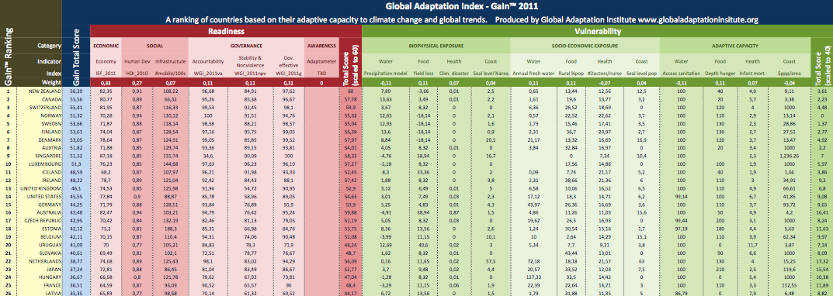

## Readiness Bar plot

Countries ordered by Readiness score. [Click for interactive plot.](https://spreadsheets.google.com/ccc?key=0AoxJVrXz_YHIdFZIcE9NbDBJX1ZSaFZxSi13UnhhVGc&hl=en&authkey=COKhgYAC%23gid=32)

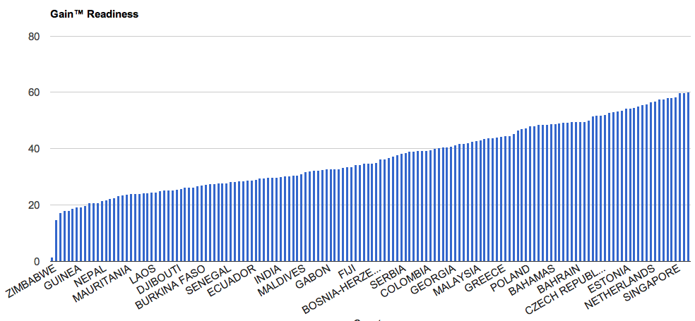

## Vulnerability Bar Plot

Countries ordered by Vulnerability score. [Click for interactive plot.](https://spreadsheets.google.com/ccc?key=0AoxJVrXz_YHIdFZIcE9NbDBJX1ZSaFZxSi13UnhhVGc&hl=en&authkey=COKhgYAC%23gid=48)

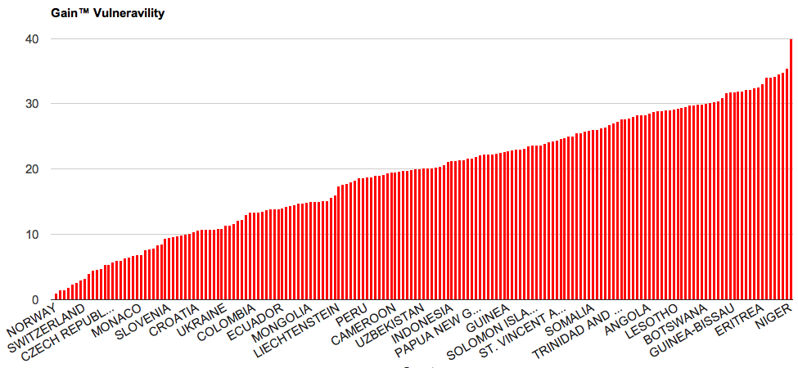

## Stackedbars

[Countries](https://spreadsheets.google.com/ccc?key=0AoxJVrXz_YHIdFZIcE9NbDBJX1ZSaFZxSi13UnhhVGc&hl=en&authkey=COKhgYAC%23gid=48) ordered [on the](https://spreadsheets.google.com/ccc?key=0AoxJVrXz_YHIdFZIcE9NbDBJX1ZSaFZxSi13UnhhVGc&hl=en&authkey=COKhgYAC%23gid=48) horizontal [axis by total Score. Blue positive and red negative stacked bars are,](https://spreadsheets.google.com/ccc?key=0AoxJVrXz_YHIdFZIcE9NbDBJX1ZSaFZxSi13UnhhVGc&hl=en&authkey=COKhgYAC%23gid=48) respectively [Readiness and](https://spreadsheets.google.com/ccc?key=0AoxJVrXz_YHIdFZIcE9NbDBJX1ZSaFZxSi13UnhhVGc&hl=en&authkey=COKhgYAC%23gid=48) Vulnerability[.](https://spreadsheets.google.com/ccc?key=0AoxJVrXz_YHIdFZIcE9NbDBJX1ZSaFZxSi13UnhhVGc&hl=en&authkey=COKhgYAC%23gid=48) [Click for interactive plot.](https://spreadsheets.google.com/ccc?key=0AoxJVrXz_YHIdFZIcE9NbDBJX1ZSaFZxSi13UnhhVGc&hl=en&authkey=COKhgYAC%23gid=49)

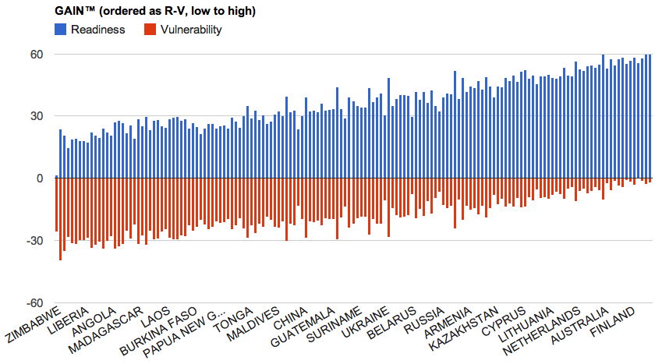

## GaIn™ Map

Ranking map. Blue shade countries have higher scores in Readiness than Vulnerability. Red shades countries have higher scores in Vulnerability than Readiness. (live draft version available [here](http://www.google.com/url?q=http%3A%2F%2Fgeocommons.com%2Fmaps%2F56384&sa=D&sntz=1&usg=AFQjCNH3okCsqB_ZsY6LqwFs4bAa0F7lRQ))

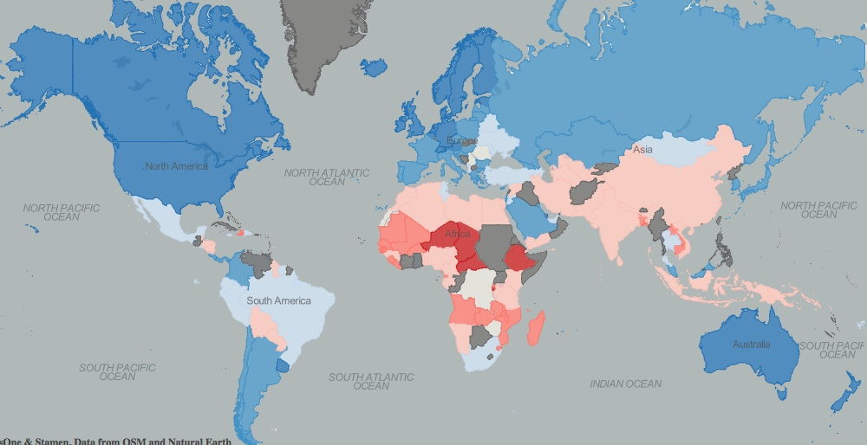

## Matrix

This represenation is based on the “Gap Minder” tool developed by Hans Rosling. It is basically a plot where X and Y axis can we chosen among the available dimenstions, but also the color and size of the data points. As we gather more data, an extra temporal dimension can we added to emphase the dinamic aspect of the data (Ignore Year labels for now). Data point can be cliked to reatin name labels, or selected through the country name list.

[Click for interactive matrix](https://spreadsheets.google.com/ccc?key=0AoxJVrXz_YHIdFZIcE9NbDBJX1ZSaFZxSi13UnhhVGc&hl=en&authkey=COKhgYAC%23gid=56) (then click on “Matrix” tab)

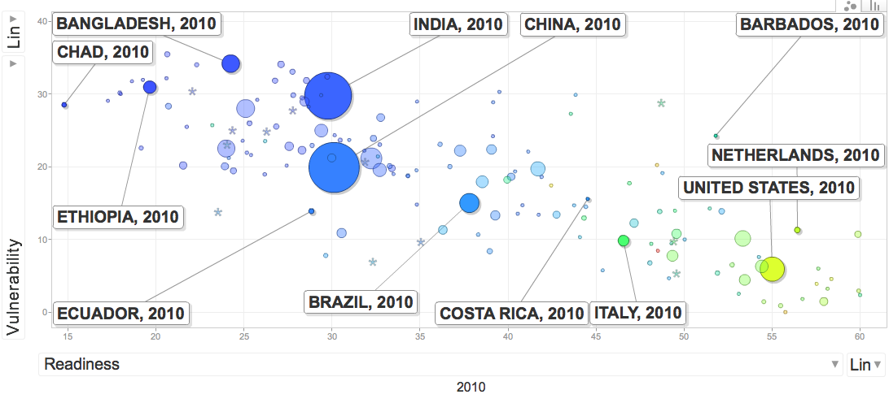

On the image above:

Abscissa Readiness

Ordinates Vulnerability

Size Population

Color GDP per capita

- For orientation purposes, some countries are labeled.

## Change in readiness

See live [here](https://spreadsheets0.google.com/ccc?key=tiXJjziKuoBO-7pboBlI4dA&authkey=CIuLi40H%23gid=56)

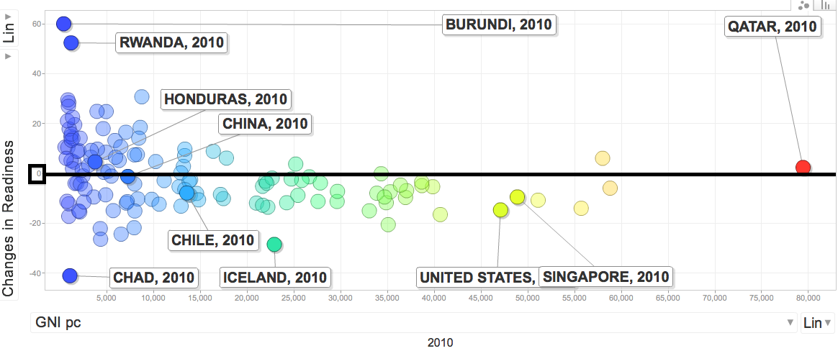

An additional dimension we provide is the deltas (% change) over the last 5 years for each of the indicators used in Readiness. We aggregate the z-values of these deltas using the same weights as for the levels. We use z-values to take into account the different stddev in each case.

## GDP correlations

In general terms GNIpc correlates both with Readiness (more strongly) and with Vulnerability. This correlation is also common for many indices in the current literature, specially for Readiness. Some Indices do, indeed, use GDP (or GNI) as one of their explicit components. In Vulnerability, we have tried to minimize this dependence, avoiding where possible, Indices durectly related or using GDP. GaIn™ intends to examine this further and determine how this correlation impacts the effectiveness of our indicators. While we believe that GNIpc strongly correlates, we still believe it is important to highlight specific indicators on which countries can make an impact or “move the needle.”

The following graphs show the apparent correlation of the “order of magnitude of GDPpc” (log GDPpc) with Readiness, Vulnerability, Total Score, and change in Readiness (size is population for all of them). All graphs are available [here](https://spreadsheets.google.com/ccc?key=0AoxJVrXz_YHIdFZIcE9NbDBJX1ZSaFZxSi13UnhhVGc&hl=en&authkey=COKhgYAC%23gid=56) (“Matrix” tab), selecting the appropriate options for the axis.

log(GNIpc) vs Readiness (color is Vulnerability)

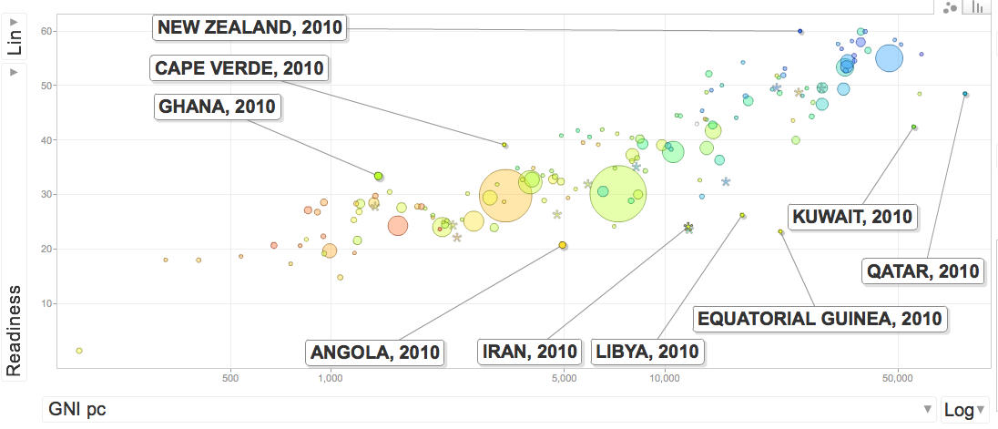

Log(GNIpc) vs Vulnerability (color is Readiness)

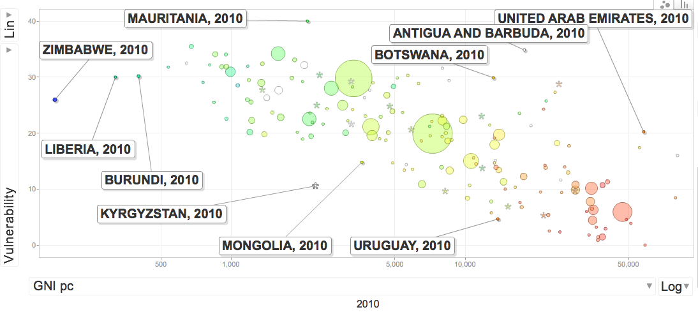

Log(GNIpc) vs change in Readiness (color is readiness)

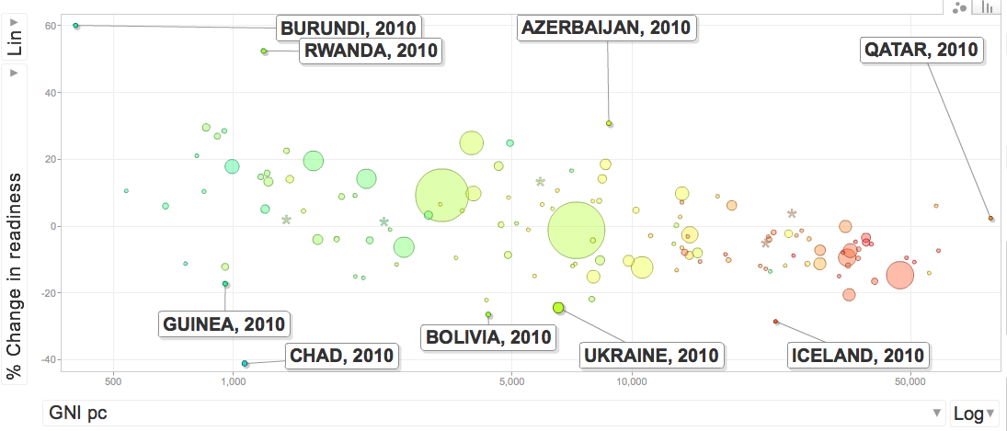

Relating GaIn™ to Country Performance

**Box 1: Example of Ranking**

**Measuring Progress**

Bangladesh, Bolivia, and Botswana show three different levels of movement on Readiness indicators. We can measure each country’s improvement or decline in economic, social, and governance indicators over the last five years as depicted in the following graph (X axis). Bangladesh has improved its overall Readiness throughout this time period while Botswana has remained stagnant. Bolivia’s level of Readiness has declined. Positive or negative movement in Readiness likely corresponds to the ability of a nation to direct investment toward climate adaptation efforts that effectively respond to the needs of its citizens.

All three currentries have high Vulnerability according to our model (the higher level on the Y axis, the more vulnerable). Currently, we have not collected enough data on Vulnerability to compare over time, however, we hope to do so and measure improvement on these indicators as well. Regardless, improvement on any of the current 12 indicators we have included will reduce a country’s Vulnerability score.

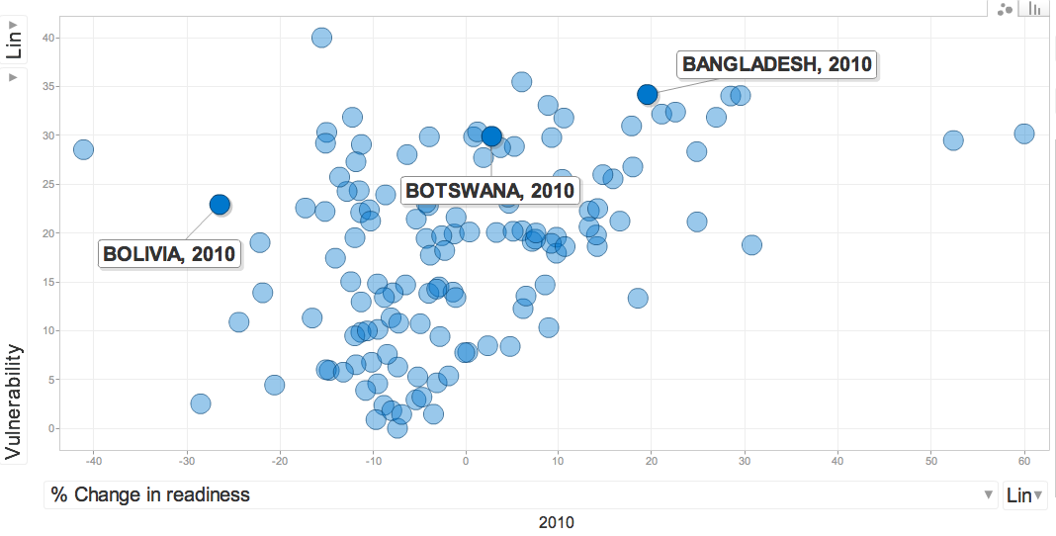

**BOX 2**

**Case 1: Bangladesh**

Bangladesh has made notable improvements on the Economic and Human Development indicators. However, to continue improving its overall Readines, it can strengthen several key areas in which it scores low relative to other countries.

*Political Stability and Absence of Violence --* a low score here, indicating a higher likelihood of government destabilization, reduces the ability of citizens and external actors (be they investors or aid agencies) to plan ahead for adaptation given the uncertainty of the future governance and regulatory environment

*Government Effectiveness* – this is another area in which Bangladesh could make significant improvements. A higher score here shows that a government is more capable of responding to the needs of ist citizens. In this case, implementing policies that facilitate improved access to water and food security in the face of climate change.

Bangladesh is a highly vulnerable country. Some conditions will be difficult to change, such as flooding from monsoons or the percentage of its coast at sea level. Changing some conditions, such as reducing percentage of the population in coastal zones, could greatly reduce vulnerability but would be very politically and economically unfeasible. It could make quicker progress on adaptive capacity indicators.

*Access to sanitation* – Bangladesh scores low here and could likely significantly decrease its vulnerability by improving infrastructure for clean washing and drinking facilities for its citizens

*Infant mortality* – a high number of child deaths represents a basic lack of health care provision for the entire population. Increasing the number of hospitals and medicine available could decrease Bangladesh’s vulnerability to new diseases that emerge from a changing climate.

**Box 3**

**Case 2: Bolivia**

Bolivia has an overall Readiness score higher than that of Bangladesh, however, it has lost ground on several indicators.

*Economic* – Bolivia has become a less attractive environment for investments. This could stifle investments in infrastructure or social services that increase resilience in water, agriculture, or health. If this leads to decreases in sanitation or agricultural capacity, quality of life may diminish or lives may be lost as climate change stresses these sectors.

Bolivia is slighlty less vulnerable than Bangladesh. However, it faces risks from decreased crop yields, climatic disasters, and a decrease in water resources. While some variable are out of Bolivia’s control, such as climatic disasters, it can become more resilient to such events by improving on several indicators.

*Doctor/nurse ratio* – Bolivia has a low ratio of doctors and nurses compared to neighboring countires. This is a slower moving indicator than others since it takes time to invest in education and training for these professions. Sill, for long term planning, increases in the number of health care providers can decrease the number of deaths, for instance, more health care professionals can help reduce mortalities due to an increase in natural disasters.

**Box 4**

**Case 3: Botswana**

Changes in Botswana’s Readiness, whether negative or positive, have been small. Had our rankings existed five years ago, Botswana would have likely hovered near its overall score of [ ]. Botswana typically scores above the median on most Readiness indicators. This could point to a situation where Botswana has already picked the „low hanging fruit,“ meaning basic regulatory and health reforms have been implemented and significant changes on Readiness indicators may require more difficult and nuance policy decisions.

*Voice and Accountability* – Botswana scores lowest on this indicator. A less free media or weaker citizen participation in government could, respectively, decrease awareness of climate threats and hamper local, regional, or national planning in protecting citizens against disasters or dwindling resources. Further, a lack of transparency and representation could allocate resources improperly – Botswana may score high on the economic indicator, increasing investment opportunities, but these investments could possibly be directed toward vested or entrenched, powerful interested that don’t reflect the needs of the citizens.

Botswana faces threats from climate disasters, potential agricultural yield losses, and decreased freshwater supplies.

Infant mortality – to move the needle on Vulnerability. Botswana could implement policies or devote resources to increasing health services. Its high infant mortality rate suggests low capacity in the health indicator.

# Next Steps

* Develop a reliable software implementation framework. Define a more robust strategy that maximizes transparency and availability. Candidates are Drupal+R+Google API.
* Continue to receive input and advice from experts. Enable appropiate channels.
* Ensure internal agreement on indicators, thought process, and underlying assumptions. Including correlation and sensitivity studies.
* Seek out, and implement advice and comments from selected collaborators and experts:

a. Add/remove indicators

b. Reconceptualize categories if necessary

* Prepare model and documentation for Join Board meeting May 2 and 3, 2011
* Implement comments, changes. Prepare for Board approval.
* Unveiling and roll out strategy. Prepare for community-wide comments.

# References

(Selected titles, a more comprehensice list of material used to prepare this work can be found [here](https://spreadsheets0.google.com/ccc?authkey=CPeQ_tMG&hl=en&key=tM7mh6gUlNp7uqWhUhx1pZw&hl=en&authkey=CPeQ_tMG%23gid=0).)

Climate Research Unit. [http://www.cru.uea.ac.uk/](http://www.google.com/url?q=http%3A%2F%2Fwww.cru.uea.ac.uk%2F&sa=D&sntz=1&usg=AFQjCNF18WR1p2sI_tH8xAtfiy6c3ic20w)

EM - DAT. The International Disaster Database. Center for Research on the Epidemiology of Disasters - CRED. [http://www.emdat.be/](http://www.google.com/url?q=http%3A%2F%2Fwww.emdat.be%2F&sa=D&sntz=1&usg=AFQjCNEqqXenUJin7H3IAhVw_EAER9kKpg)

Fussel, Hans-Martin. 2010. How inequitable is the global distribution of responsibility, capability, and vulnerability to climate change. Global Environmental Change (20) 597-611.

Fussel, Hans-Martin. 2009. Review and Quantitative Analysis of Indices of Climate Change Exposure, Adaptive Capacity, Sensitivity, and Impacts. Background note to the World Development Report 2010. World Bank, Washington, D.C. [http://wdronline.worldbank.org/worldbank/a/nonwdrdetail/145](http://www.google.com/url?q=http%3A%2F%2Fwdronline.worldbank.org%2Fworldbank%2Fa%2Fnonwdrdetail%2F145&sa=D&sntz=1&usg=AFQjCNHNM1Z4zj9nRQ1LAmp_7YnlaY2w4Q)

Index of Economic Freedom. 2011. Heritage Foundation and Wall Street Journal. [http://www.heritage.org/index/](http://www.google.com/url?q=http%3A%2F%2Fwww.heritage.org%2Findex%2F&sa=D&sntz=1&usg=AFQjCNGQZ6skokRvi1-7UyGzOvh5krb4IA)

Kaufmann, Daniel, Kraay, Aart, & Mastruzzi, Massimo. World Governance Indicators. World Bank. [http://info.worldbank.org/governance/wgi/index.asp](http://www.google.com/url?q=http%3A%2F%2Finfo.worldbank.org%2Fgovernance%2Fwgi%2Findex.asp&sa=D&sntz=1&usg=AFQjCNFnQdUJxcMmuS-Y8MjLmb8VA3lFKA)

SEDAC, 2007. National Aggregates of Geospatial Data Collection. Population, Landscape and Climate Estimates (PLACE). [http://sedac.ciesin.columbia.edu/place/](http://www.google.com/url?q=http%3A%2F%2Fsedac.ciesin.columbia.edu%2Fplace%2F&sa=D&sntz=1&usg=AFQjCNHN-rKBJMBe8exEDT8dKNKynyaI2A)

UNDP. Human Development Index. [http://hdr.undp.org/en/statistics/hdi/](http://www.google.com/url?q=http%3A%2F%2Fhdr.undp.org%2Fen%2Fstatistics%2Fhdi%2F&sa=D&sntz=1&usg=AFQjCNFDVsqZXA9A_y1V8r2M8ElDfLmAHg)

Wheeler, David. 2011. Quantifying Vulnerability to Climate Change: Implications for Adaptation Assistance - Working Paper 240. Center for Global Development.

[http://www.cgdev.org/content/publications/detail/1424759](http://www.google.com/url?q=http%3A%2F%2Fwww.cgdev.org%2Fcontent%2Fpublications%2Fdetail%2F1424759&sa=D&sntz=1&usg=AFQjCNFhy5Ac7tAyS-7h9a7arwHzmtuzfA)

World Bank. Country Policy and Institutional Assessments (CPIA), 2009 Assessment Questionnaire. September 10, 2009.

World Bank Development Indicators (WDI). World Bank.

http://www.data.worldbank.org/indicators

World Telecommunicationn/ICT Indicators Database. International Telecommunications Union. [http://www.itu.int/en](http://www.google.com/url?q=http%3A%2F%2Fwww.itu.int%2Fen&sa=D&sntz=1&usg=AFQjCNEJ7gj_9TInwWeBOlqwUaHtMCdBjQ)

**Submission form** available here (anyone can send reviews): [**http://bsan.eu/Gain_biblio_form**](http://www.google.com/url?q=http%3A%2F%2Fbsan.eu%2FGain_biblio_form&sa=D&sntz=1&usg=AFQjCNHHUPRGWpV8n0qf_B-qoFZSzz9djA)

# Appendix 1: Methodology

**Normalization**

Score values are converted to standard scores (z-values). Z-values subtract score values to the average score for all the countries, and then divide by the standard deviation of those scores. The resulting measure compares values relative to other countries in units of stdev. If all values are clustered, the unit is small (higher granularity). If values are dispersed, or a few deviate significantly from the mean, the granularity is coarse.

**Evaluate**

**Orthogonality/Correlations**

Indices are not perfectly orthogonal (Independent) between Readiness and Vulnerability, or even among Categories. We also do not assume that the set of indices is complete in terms of all parameters. We chose the smallest set of indices that provide the most information. Correlations among indicators and with other variables like GDPpc are possible and expected.

**Missing or outdated data**

If a country has missing data, we remove it entirely from the model. In some cases we fill the most sensible value. Like for example landlocked countries and sea-level rise effect, or adding a 0 value for victims on climate disasters in the CRED database.

# Appendix 2: Glossary of Terms

|  |  |
| --- | --- |
| *Adaptometer* | an indicator that captures information from the field that describes the level of knowledge, the policies in place, the allocation of budgets, and the overall commitment of society to adapting to climate change and other global trends. The adaptometer will not only capture the “awareness” of the public and government on adaptation but what actions are being formulated and implemented. |
| *Awareness* | a concept that captures the reality on the ground, a society’s understanding of climate risks, and the prospects of change in the right direction for increasing adaptation capacity. |
| *Biophysical impacts* | the level of adverse biophysical impacts due to climate change and other global forces |
| *Fast indicator* | an indicator that can change quickly, primarily due to human actions. Most Readiness and adaptive capacity indicators are fast indicators. |
| *GaIn™* | Global Adaptation Institute. A non-profit environmental organization guided by a vision of building resilience against climate change and other global forces as a key component to sustainable development. The mission of GaIn™ is to enhance the world’s understanding of the urgency for adaptation to climate change and other global forces and for the support needed through private and public investments for developing countries. |
| *Medium indicators* | an indicator which can change over time due to human actions. However, change may take place slowly, over decades rather than years. |
| *Readiness* | a country’s existing preparations and ability to adapt to a changing climate. |
| *Readiness Matrix* | a measurement of the comparative resilience of countries, plotting a country’s vulnerability to climate change with its readiness to confront climate challenges. |
| *Slow indicator* | an indicator, usually physical, that moves very slowly or may not change in a lifetime. Human action has little impact on changes in these variables. |
| *Socioeconomic exposure* | the importance of a climate-sensitive sector to a country. In other words, how exposed or sensitive a country is to impacts on water, food, coastal zones, and human health. |
| *Socioeconomic adaptive capacity* | the availability of economic, social, and institutional resources to cope with and adapt to the impacts of climate change in specific sectors. Though related, this differs from Readiness indicators in that it measures specific actions taken to increase resilience in specific sectors, whereas Readiness measures a country’s ability to easily facilitate these increases in resilience. |
| *Vulnerability* | a country’s socioeconomic exposure to biophysical impacts minus adaptive capacity |
| *Weight* | the relative value or importance an indicator is assigned in determining a country’s overall Readiness and Vulnerability score. |

# Appendix 3: October 27 Bolger Center Scientists Meeting (2010)

Claudio Szlafstein, Professor of the Environmental Science Center at the Federal University of Parana in Brazil.

Nicholas Brooks, Visiting Research Associate at the School of Geography and the Environment at the University of Oxford

Heather McGray, Senior Associate at the World Resources Institute

Ian Noble, Lead Climate Change Specialist at the World Bank.

Lisa Horrocks, Knowledge Leader in Adaptation at AEA (England)

William Clark, Harvey Brooks Professor of International Science, Public Policy and Human Development, at Harvard University

Robert A. Edwards, Managing Director for NGP GAP.

Mark Myers, State of Alaska Natural Gas Pipeline Coordinator and Vice-Chancellor for Research at the University of Alaska Fairbanks.

Caroline Sullivan, Associate Professor, School of Environmental Science and Management, Lismore, Australia.

Mike Toman, Lead Economist on Climate Change at the World Bank

Richard Moss, Vice President and Managing Director for Climate Change at the World Wildlife Fund

Marc Miles, Global Strategy Consultant

Mark Klugmann, Communications and Strategy Consultant

Later during the morning, the following individuals arrived

Daniel Kaufmann, Senior Fellow, Global Economy and Development Program at the Brookings Institution

Richard Stewart, John Edward Sexton Professor of Law at the New York University.

Dr. Anand Patwardhan, Professor at the Indian Institute of Technology

# Appendix 4: Roadmap (tentative)

|  |  |  |  |
| --- | --- | --- | --- |
| Working Model | 3 Weeks | Feb. 21 – March 15 | |
| Tasks | **Purpose** | Registration | **POC** |
| Research assembly | * For use by Dr. Daboub and Institute to present to outside audience | Bibliography accessible on google docs here: <http://goo.gl/GCaP1> | Bruno  Davis |
| Review of indices | * For use by Dr. Daboub and Institute to present to outside audience | Indices listed as part of bibliography | Bruno  Davis |
| Components | * Indicators and indices for use in draft model | Discussed in “Scoping Gain” document found here: <http://goo.gl/oalkI> | Bruno  Davis |
| First draft model | * For use internally for GaIn™ to test with trusted experts. | Explanatory document for model found here:  Model found here: <http://goo.gl/oalkI> | Bruno |
|  | | | |

|  |  |  |  |
| --- | --- | --- | --- |
| “Family” Consultation | 2 Weeks | March 21 – April 1 | |
| Tasks | **Purpose** | **Registration** | **POC** |
| Draft White Paper | * White paper will explain model, purpose of model, and underlying assumptions | Continue on google docs | Team |
| Vulnerability Feedback | * Bill Clark; Lisa Horrocks; Caroline Sullivan |  | Ian |
| Readiness Feedback | * Pablo Pilar; Ricardo Housmann |  | Marc |
| Dani Kaufmann Feedback | * Dani Kaufmann |  |  |
| Prepare for brownbags | * Research NGOs * Invite guests |  | Andrea  Davis |
| Guidelines for 1st Review Process:   1. A selected number of reviewers are given the documentation and asked for comments. This would be the 4-5 we had in mind (Dani, Lisa, ...). Ideally we speak with them and explain the process, answering their questions. 2. They suggest modifications that we respond to (not all modifications will be implemented but we´ll try). 3. After the modifications, they are asked to "sign" the first working model if they agree with the content of this version (a "not yet final" model). 4. They also provide a list of prospective reviewers | | | |
|  | | | |

|  |  |  |  |
| --- | --- | --- | --- |
| Counsel of Scientists Review, Further Research, & Data Migration | 4 Weeks | April 1 – April 30 | |
| Tasks | **Purpose** | **Registration** | **POC** |
| Send model and White Paper to counsel of scientists | * Targeted interviews with leading experts; understanding prior work * Assess the pros/cons of our approach |  |  |
| Brownbag w/ NGOs, scientists, and think tanks | * Gain wide feedback not only on our model but on what others are doing |  | Carmen |
| Migrate model framework | * Migrate away from google docs taking into consideration feedback from counsel of scientists * Create Drupal skeleton * Incorporate revision history and results * Bibliography * Ticket system | * Drupal? | Marc  Bruno |
| Assess competitive landscape | * What other indices exist. * Why have they succeeded or failed * How are we different * Collaboration |  |  |
| Determine summer post-COS consultation | * More scientists? Institutions? |  |  |
| Create outreach database | * Lists of organizations, institutions, key country contacts |  |  |
| Prepare for Joint Board meeting | * New intern |  |  |
| Guidelines for 2nd Review Process:  Same process as with the First round. | | | |
|  | | | |

|  |  |  |  |
| --- | --- | --- | --- |
| Expanded Consultation Process and Improvements | 2 Months | May 1 – July 1 | |
| Tasks | **Purpose** | **Registration** | **POC** |
| Joint Board Meeting | Present improved version of GaIn™ model based on counsel of scientist comments |  |  |
| Begin Adaptometer research and consultation | This process should begin early for inclusion in a 2012 model  Research feasibility and costs of undertaking |  |  |
| Research indicators on energy/other sectors | Consult with available experts |  |  |
| Prepare communications and outreach strategy for rollouts | Decide on visual device to communicate  Plan the rollout; which countries, which businesses, which NGOs to target  Write op/eds. Leverage database for greater insights  Maintain and develop more country contacts |  |  |
| Implement COS recommendations |  |  |  |
| Improve website | Use website to communicate work  More interactive  Garner feedback/connect with key players |  |  |
| Guidelines for 3rd Review Process:   1. The model is published on the web, along with the documentation. We also provide forms for feedback and a deadline to receive them. 2. Anyone can provide a list of suggested modifications. Feedback has to include names and affiliation. The list of name and affiliation will be public after the model is unveiled (we will not publicly link reviews to reviewers) -- reviewers need to agree to that. 3. We perform the suggested modifications to the model and the documentation. We checkmark every comment (without stating the reviewer) and, when such, why we didn´t implement their recommendations. This document is kept confidential to the Board of Scientist. 4. After modifications, the model is approved and signed by the Council of Scientist and signed by the Board. 5. On the Documentation we include a list of names and affiliation of reviewers (not their review comments). We include a list of Reviewers and a statement that they have reviewed the draft and suggested modification that we considered. They are not shown the final version, not asked to agree with it or sign it. 6. Unveiling: We enter continuous review were we accept comments for the next round. | | | |
|  | | | |

|  |  |  |  |
| --- | --- | --- | --- |
| Finalization of V.1 | 1 Month | July 1 – 30 | |
| Tasks | **Purpose** | **Registration** | **POC** |
| Finalize White/Explanatory Paper | * To accompany any online model or as a published document |  |  |
| Incorporate other sectors/energy |  |  |  |
| Create explanatory video | * To help engage the user |  |  |
| Ensure ease of use of model | * Have a few trusted sources unfamiliar with our work use the model |  |  |
|  | | | |

|  |  |  |  |
| --- | --- | --- | --- |
| Unveiling & Rollout | ----- | August/September | |
| Tasks | Purpose | Registration | POC |
| GaIn™ staff participate in press conferences | * At the National Press Club (U.S); Sao Paulo; London; Dhaka; etc… |  |  |
| GaIn™ takes part in late summer/fall conferences | * Clinton Global Initiative * Focus on both environment AND development sectors |  |  |
| Target a few countries | * Environment ministers of Mexico, Bangladesh, El Salvador, etc… commit to considering GaIn™ indicators in environmental planning |  |  |
|  | | | |

1. Throuout this document we use hiperlinks that, when clicked, direct to the appropiate section of the Model, which is hosted online. If this is a printout, you can always access it on this address: http://[bsan.eu/Gain_v05](http://bsan.eu/Gain_v05) (within the spreadsheet, refer to the appropiate Sheet Tab in the lower section of the page).
2. Ibid
3. Fussel, Hans-Martin. 2009. Review and Quantitative Analysis of Indices of Climate Change Exposure, Adaptive Capacity, Sensitivity, and Impacts. Background note to the World Development Report 2010. World Bank, Washington, D.C. [http://wdronline.worldbank.org/worldbank/a/nonwdrdetail/145](http://www.google.com/url?q=http%3A%2F%2Fwdronline.worldbank.org%2Fworldbank%2Fa%2Fnonwdrdetail%2F145&sa=D&sntz=1&usg=AFQjCNHNM1Z4zj9nRQ1LAmp_7YnlaY2w4Q)
4. We use this indicator instead of 3 suggested by Fussel. This gets to the core concept and is more readily available than Fussel’s citations. We do the same for several other indicators suggested by Fussel for which data is not easily attainable.